My Picture Calendar Aug 29 – Oct 9, 2021
Sunday | Monday | Tuesday | Wednesday | Thursday | Friday | Shabbos
29 | 30 | 31 | 9/1 | 2 | 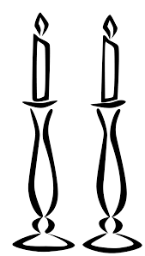  3 | 4
5 | 6 | 7 | 8 | 9 | 10 | 11
12 | 13 | 14 | 15 | 16  Yom Kippur | 17 | 18
19 | 20 | 21 | 22 | 23 | 24 | 25
26 | 27 | 28 | 29 | 30 | 10/1 | 2
3 | 4 | 5 | 6 | 7 | 8 | 9

