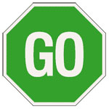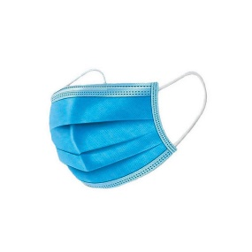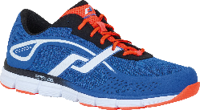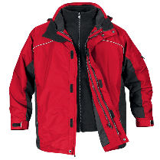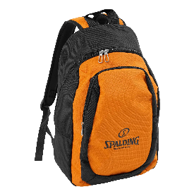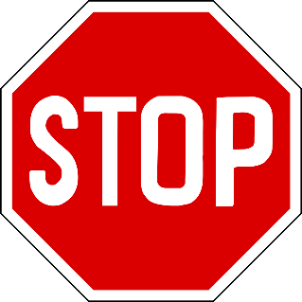



[This Photo](https://en.wikipedia.org/wiki/File:Check_mark.svg) by Unknown Author is licensed under [CC BY-SA](https://creativecommons.org/licenses/by-sa/3.0/)



[This Photo](https://en.wikipedia.org/wiki/File:Check_mark.svg) by Unknown Author is licensed under [CC BY-SA](https://creativecommons.org/licenses/by-sa/3.0/)



[This Photo](https://en.wikipedia.org/wiki/File:Check_mark.svg) by Unknown Author is licensed under [CC BY-SA](https://creativecommons.org/licenses/by-sa/3.0/)



[This Photo](https://en.wikipedia.org/wiki/File:Check_mark.svg) by Unknown Author is licensed under [CC BY-SA](https://creativecommons.org/licenses/by-sa/3.0/)

**COAT**

**SHOES**

**KNAPSACK WITH LUNCH**

**Have a great day!**

**MASK**

**AM I WEARING MY:**